|  |
| --- |
| Name: U W M N A Udakumbura |
| Student Reference Number: 10707395 |



|  |  |  |
| --- | --- | --- |
| Module Code: SOFT255SL | Module Name: Software Engineering for the Internet using Java | |
| Coursework Title: Final Assignment | | |
| Deadline Date: Wednesday, 28 April 2021, 11:30 AM | | Member of staff responsible for coursework:  Mr. Kaneeka Vidanage |
| Programme: BSc (Hons)Software Engineering | | |
| Please note that University Academic Regulations are available under Rules and Regulations on the University website [www.plymouth.ac.uk/studenthandbook](http://www.plymouth.ac.uk/studenthandbook). | | |
| Group work: please list all names of all participants formally associated with this work and state whether the work was undertaken alone or as part of a team. Please note you may be required to identify individual responsibility for component parts.  **GROUP – 21**  **U W M N A Udakumbura - 10707395**  **V P N Sulakshika – 10707385**  **H S Kaushalya - 10707241**  **P D S Sigera - 10707372**  **D L S Akbo - 10707126**  ***We confirm that we have read and understood the Plymouth University regulations relating to Assessment Offences and that we are aware of the possible penalties for any breach of these regulations. We confirm that this is the independent work of the group.***  Signed on behalf of the group:A picture containing flying, outdoor, whiteboard, day  Description automatically generated | | |
| Individual assignment: ***I confirm that I have read and understood the Plymouth University regulations relating to Assessment Offences and that I am aware of the possible penalties for any breach of these regulations. I confirm that this is my own independent work.***  Signed: | | |
| Use of translation software: failure to declare that translation software or a similar writing aid has been used will be treated as an assessment offence.  I *have used/not used translation software.  If used, please state name of software………………………………………………………………… | | |
| **Overall mark _____% Assessors Initials ______ Date_________** | | |

*Please delete as appropriateSci/ps/d:/students/cwkfrontcover/2013/14

Table of Contents

INTRODUCTION 4

FLOWCHART 5

UML DIAGRAMS 6

EXPLANATION OF USER INTERFACES 8

CONTRIBUTION OF GROUP 18

MEMBERS 18

CONCLUSION 19

[THANK YOU! 20](https://d.docs.live.net/b2db611801df5fc3/Desktop/New%20folder/Hospital%20Management%20System%20-%20Group%2021/10707395%20-%20Group%2021.docx#_Toc70516828)

# INTRODUCTION

# 

* With the increase in the need of healthcare in recent years hospitals have become busier and they might not be able to manage their work as usual. So, we have created a hospital management system to meet all the needs of the different users. Here we created a website and there are three main parties involved in the process. They are the reception / administration staff, doctors, and patients. It is more like an all-in-one site where the users can satisfy their needs by using the same web site.
* Here the reception has most of all the access. They can create appointments for patients, update, delete, and view the added patients. Also, the reception can add, update, delete and view the added doctors. Then the doctors can update their profile by login into their account from the home page. Moreover, the patient can register and update their profile after login to their accounts and make appointments for their desired doctor. This is the overall process which happens in our project.
* We made this project using J2EE, servlets and JSP pages. We designed and created the web pages using html and CSS. The web pages are described below by using screenshots and we attached the GitHub link so the project can be seen there when needed by using the link.
* Also, we designed an UML model diagram to showcase the overall idea of the project and a flowchart to further understand how the process goes. We have the screenshot of the database for further reference. Finally, this is the overall idea of the project and further understandings and clarifications can be done while going through the report.

# FLOWCHART

# UML DIAGRAMS

TASK SPECIFIC UML DIAGRAM

**ACTIVITY DIAGRAM**

# EXPLANATION OF USER INTERFACES

HOME PAGE

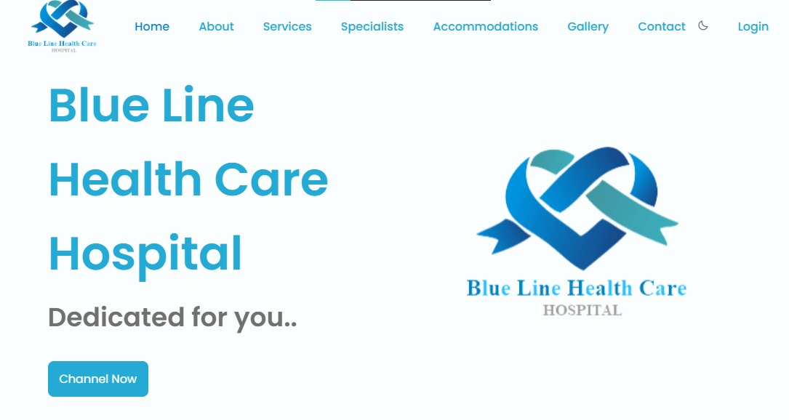

* This is the home page of Blue Line Health Care Hospital. When the user goes to the site this is how it will be displayed.
* Our hospital goes to a blue color theme therefore we used blue and white to design the rest interfaces.
* We have used a Channel Now button to redirect it to the necessary pages.

MANAGEMENT PAGE



* After clicking the Channel Now, the above web page will be displayed.
* Here we have divided logins in to three sections of Patients, Doctors, and Staff.
* After clicking on the necessary option, it will be redirected to the necessary page.

PATIENT LOGIN

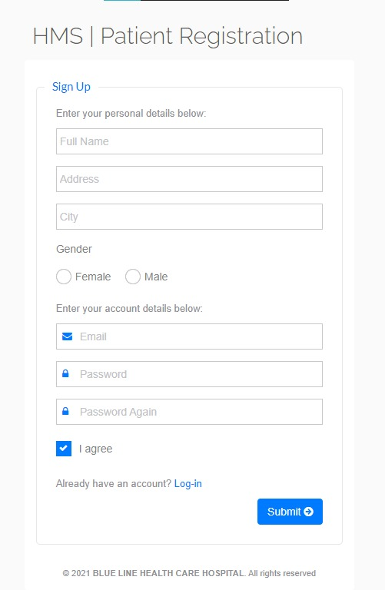

* After clicking the patient login option, they will be a form displayed asking to register.
* Here a new patient can register with the system by entering their details mentioned above.
* After filling this form, they must click on the submit button to submit the form.
* If that patient already has an account, they can choose the login option displayed below in the web page.

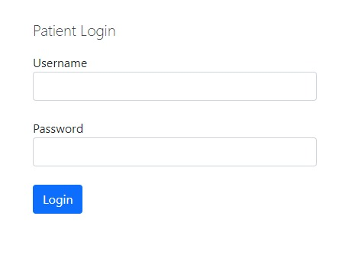

* After clicking on to the login option, they will see the above page asking them to login into their accounts.
* The user can only login to their accounts if they have already registered with the system.
* After entering the username and the password they can log in to their accounts.

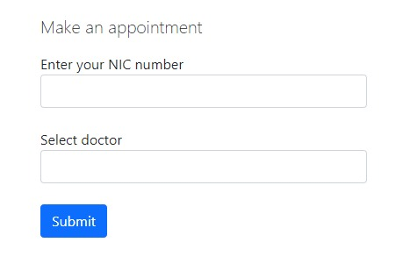

* After logging into the account, the patient can make an appointment for their desired doctor.
* By entering the NIC Number and the and choosing the doctor by the dropdown and clicking on the submit button they can make the appointment.

DOCTOR LOGIN

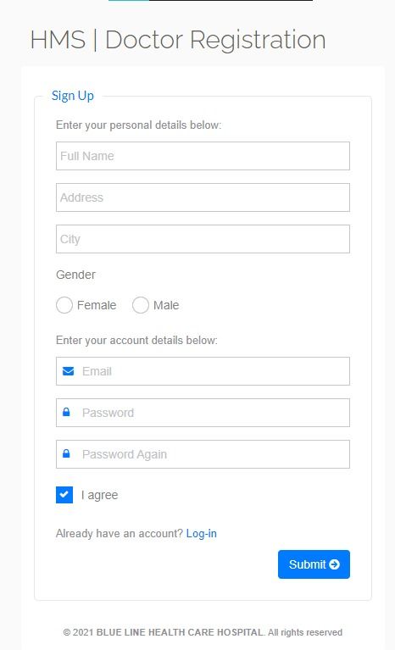

* If the user clicks the Doctors login from the main login window, they will be redirected to the doctor’s registration form.
* Here it is same with the patient registration. If the doctor is a new doctor, they must fill the above form and then click on the submit button.
* If the doctor is an already registered member with the system, they can go with the Login option to straightly login to their accounts.

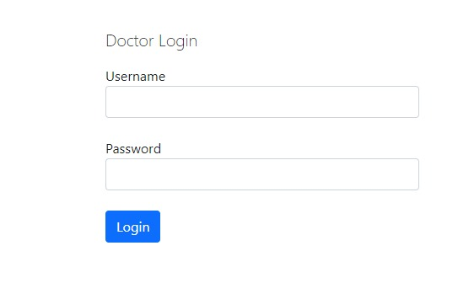

* Here after choosing the login link from the previous web page the already registered doctors will see this form asking them to fill their username and password.
* So, by filling the required fields and clicking the login button they will be redirected to the doctor’s dashboard.

ADMIN LOGIN

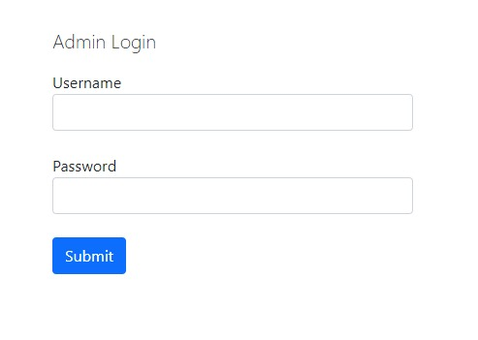

* Here there is an admin login which we created for the administration staff/ reception.
* Here after entering the given username and password admin will log into their account.
* The credential of the admin is:
* Username – admin
* Password – pass
* After giving the above credentials and clicking on the submit button the admin will log into the account.

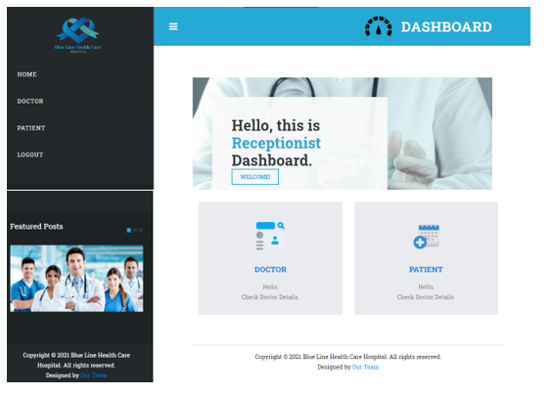

* After login into the account the above UI will be displayed asking the admin to choose an option between Doctor and the Patient.

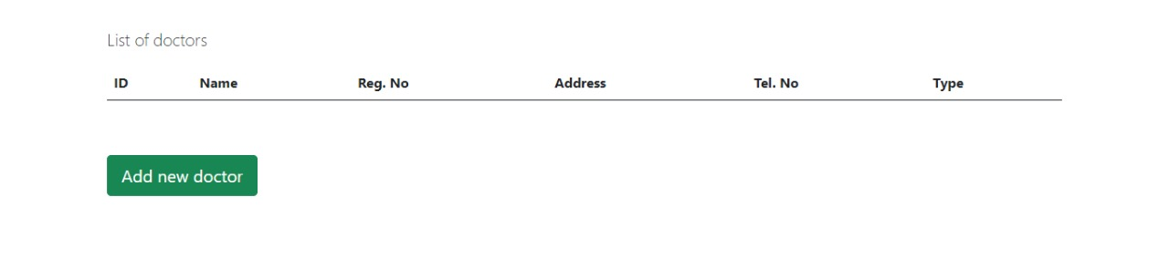

* If the admin clicks on the Doctor button, the list of Doctors will be displayed who have registered to the system.

SCREENSHOTS OF THE DATABASE

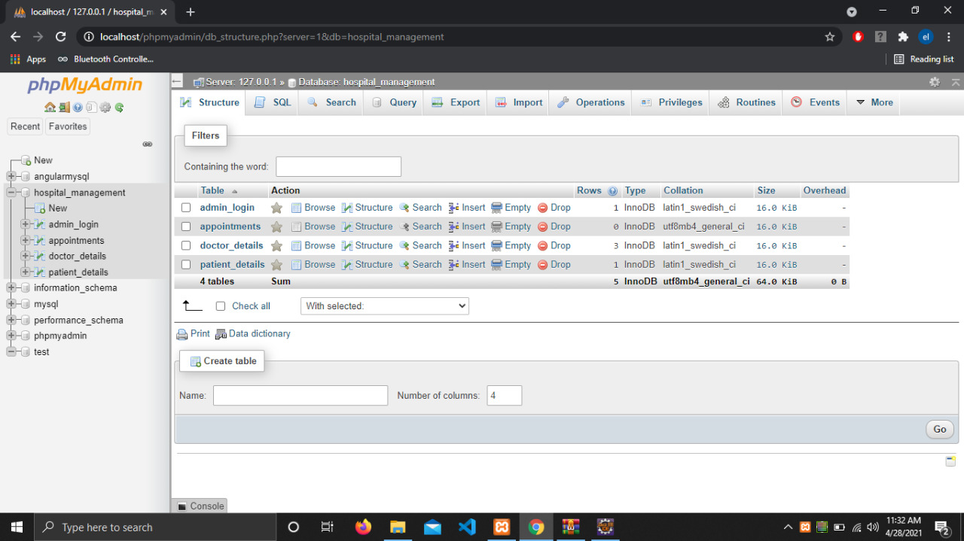

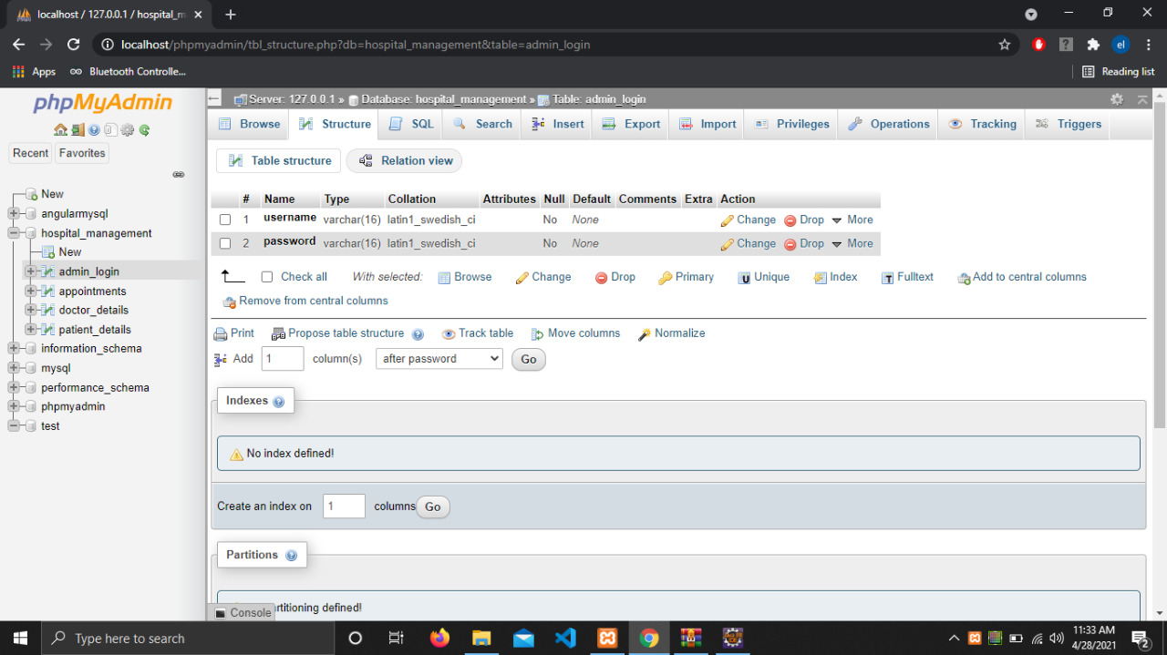

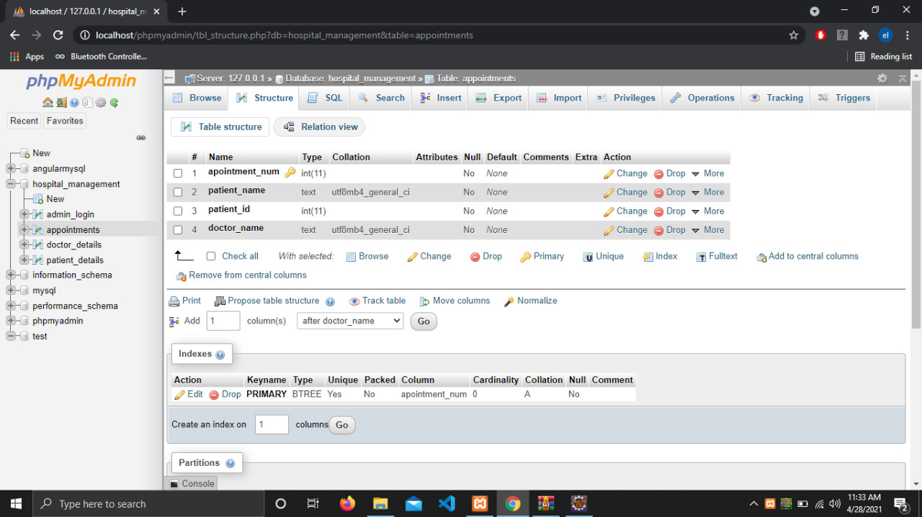

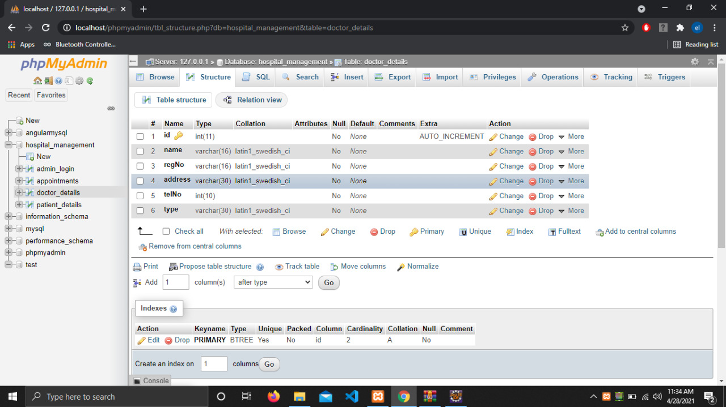

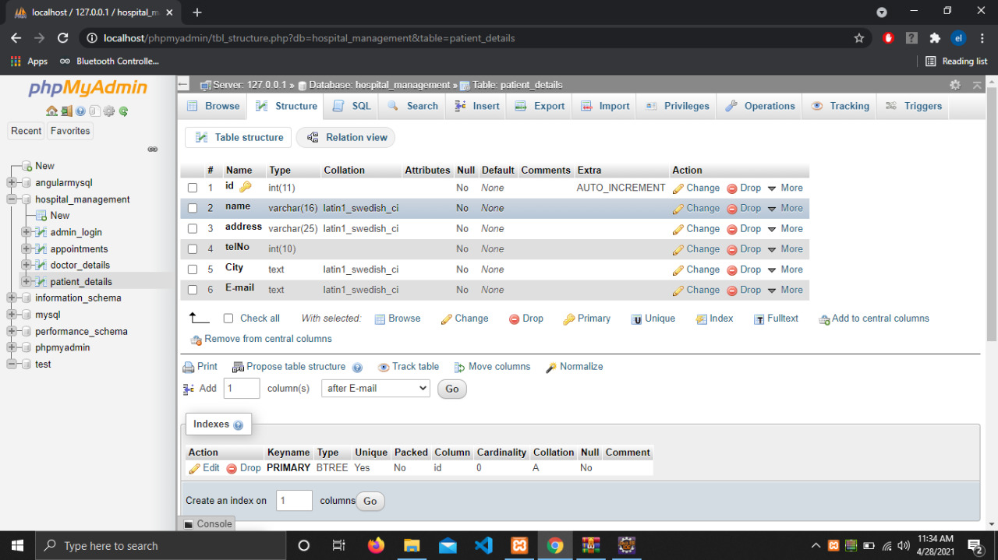

# CONTRIBUTION OF GROUP

# MEMBERS

|  |  |  |
| --- | --- | --- |
| NAME | PLYMOUTH ID | CONTRIBUTION |
| 10707395 | U W M N A Udakumbura | Admin controls for doctor (Add doctor, update doctor, view doctor, delete doctor). |
| 10707385 | V P N Sulakshika | Admin controls for patient (Add patient, update patient, view patient, delete patient). |
| 10707241 | H S Kaushalya | Patient register, patient making appointments. |
| 10707372 | P D S Sigera | Update doctor profile, patient profile. |
| 10707126 | D S L Akbo | Admin login,  Database. |

# CONCLUSION

* As we have discussed above that is the overall idea of the project and what it does. Any further alterations and adding can be done to the project but we just showed the basic functions that can be done in our hospital management system.

* As in conclusion we would like to say that we gained lot of experience when building this site like how to work with servlets and the linkages of different java pages, JSP and more, specially how to work in a team. Also, we would like to thank our module leader Mr. Kanneka Vidanage who gave us this project which tend us to think in different areas and which improved our coding knowledge as well. We faced lot of challenges while making this project, but we think as a team we have achieved that task well and made this project a success as expected.

# THANK YOU!



